1. – Design

Contents

3.1 Breakdown of Problem 2

3.11 Justification of Breakdown 2

3.12 Links between Objectives and Sub Problems 3

3.2 Input and Output Designs 4

3.21 Identification of Data 4

3.22 Designs of Input & Output 5

3.3 Files & Data Structures 6

3.31 Entity Relationship Diagram 6

3.32 Methods of Access inc. Files 7

3.33 Data Structure Designs 8

Staff.java 8

???.java 8

3.4 Validation 9

3.5 Processes 10

3.51 Objectives Links with Data/Files 10

3.52 Processing Routines 11

# Breakdown of Problem

## 3.11 Justification of Breakdown

Lorem ipsum dolor sit amet, consectetur adipiscing elit. Vestibulum a auctor dolor, et venenatis urna. Curabitur vitae sapien eget metus tincidunt pellentesque. Duis fermentum urna id erat aliquam, at aliquam odio volutpat. Nunc vestibulum sem vitae orci varius fringilla. Nam rutrum dolor ipsum, nec ultrices massa elementum eu. Integer a nibh fermentum, dapibus lectus a, viverra quam. Phasellus sed lectus viverra, aliquet ex at, commodo leo. Sed porta magna neque, at tempor nulla interdum at. Nullam massa leo, tempor porta mollis a, lacinia porttitor metus. Sed at eros a risus aliquet feugiat. Cras nisi felis, dignissim eu risus vitae, rutrum pharetra libero. Donec tempus nisi et sapien semper tempor.

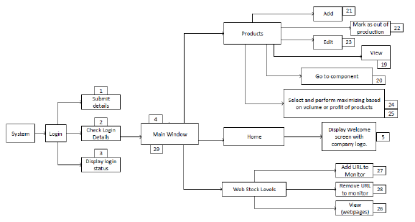

## 3.12 Links between Objectives and Sub Problems

|  |  |  |
| --- | --- | --- |
| Objective # (Investigation) | Objective Description  (Investigation) | Sub-Problem #  (Breakdown Diagram) |
| 1 | Submit Login Details | 1 |
| 2 | Check Login Details | 2 |
| 3 | Display Login Details | 3 |
|  |  |  |
|  |  |  |

# 3.2 Input and Output Designs

## 3.21 Identification of Data

|  |  |  |  |  |
| --- | --- | --- | --- | --- |
| File / Screen Name | Feature | Input/ Output | Data Used | Consideration of Data Used |
| Home | Login? | Input | Username, Password |  |
| Staff | Add? |  | * Staff ID * Name * Etc. |  |
| Staff | Search by? |  |  |  |
| Staff | Edit? |  |  |  |
| 3rd Screen | Search by?, |  |  |  |
| 3rd Screen | Sort by?, |  |  |  |
| 3rd Screen | Filter by? |  |  |  |
| Reports? |  |  |  | Printable ???? |
| etc |  |  |  |  |

## 3.22 Designs of Input & Output

|  |  |  |  |  |
| --- | --- | --- | --- | --- |
| ADD  SCREEN / DCF / REPORT  DESIGN HERE  (1 of these for each) | | | | |
| THIS DESIGN WAS CREATED IN MS-VISIO AND IS NOT AN IMPLEMENTATION | | | | |
| Name of Design | **Description of Design & Purpose** | **Components Used & Justification** | **Font: Type, Colour, Size** | **Objective #’s met** |
| Staff Form |  |  |  |  |

# 3.3 Files & Data Structures

## 3.31 Entity Relationship Diagram

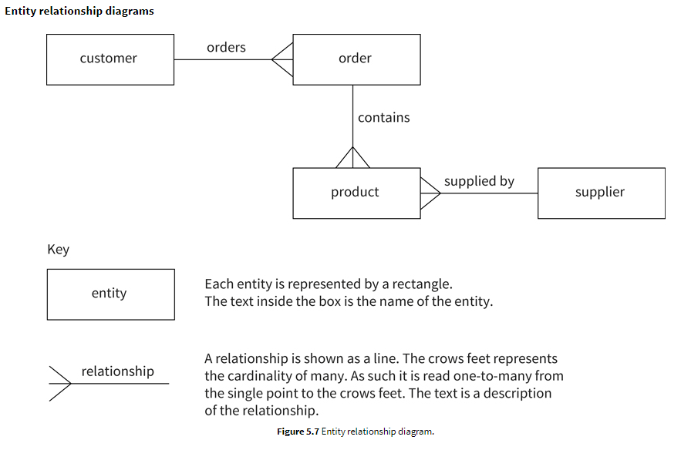

## 3.32 Methods of Access inc. Files

|  |  |  |  |  |  |
| --- | --- | --- | --- | --- | --- |
| Entity | Classes | Expected # of Records | Storage  (Files & Arrays) | Method of Access | Justification for Method of Access |
| *Staff* | *Staff.java*  *StaffList.java* |  |  | *Serial, Sequential, Random Access* | * *Number of records to access* * *Search techniques and categories* * *How often accessed* * *Use (temporary/permanent.* * *Disadvantages of other options* * *Programming time required* |
| *??* | *??.java* |  |  |  |  |
|  |  |  |  |  |  |
|  |  |  |  |  |  |

## 3.33 Data Structure Designs

### Staff.java

|  |  |  |  |  |  |
| --- | --- | --- | --- | --- | --- |
| Field Name | Key Field | Description | Data Type | Length | Example Data |
|  | *PK* |  |  |  |  |
|  | *FK* |  |  |  |  |
|  | - |  |  |  |  |
|  | - |  |  |  |  |

### ???.java

|  |  |  |  |  |  |
| --- | --- | --- | --- | --- | --- |
| Field Name | Key Field | Description | Data Type | Length | Example Data |
|  | *PK* |  |  |  |  |
|  | *FK* |  |  |  |  |
|  | - |  |  |  |  |
|  | - |  |  |  |  |

# 3.4 Validation

|  |  |  |  |  |  |
| --- | --- | --- | --- | --- | --- |
| # | Class | Field | Val. Type | Val. Rule/Description | Error Message |
| *1* | *Staff.java* | *???* | ***Type / Length / Format /Range / Lookup / Presence*** |  |  |
|  |  |  |  |  |  |

# 3.5 Processes

## 3.51 Objectives Links with Data/Files

|  |  |  |
| --- | --- | --- |
| Objective #  (Investigation) | Process / Objective Desc  (Investigation) | Data/Files Used |
| 1 | Submit Login Details | Username,Password |
| 2 | Check Login Details | Users.txt |
| 3 | Display Login Details | Username,Password |
|  |  |  |
|  |  |  |
|  |  |  |
|  |  |  |
|  |  |  |
|  |  |  |
|  |  |  |
|  |  |  |
|  |  |  |
|  |  |  |
|  |  |  |
|  |  |  |

## 3.52 Processing Routines

|  |
| --- |
| **// Objective 1 – Add 2 numbers:**  **START**  **SET** number1=0  **SET** number2=0  **INPUT** number1  **INPUT** number2    **OUTPUT** “The Answer is “, (number1+number2)  **END** |
| **// Objective 2 - ???** |
| **// Objective 3 - ???** |
|  |